1. Click Get Data in menu bar

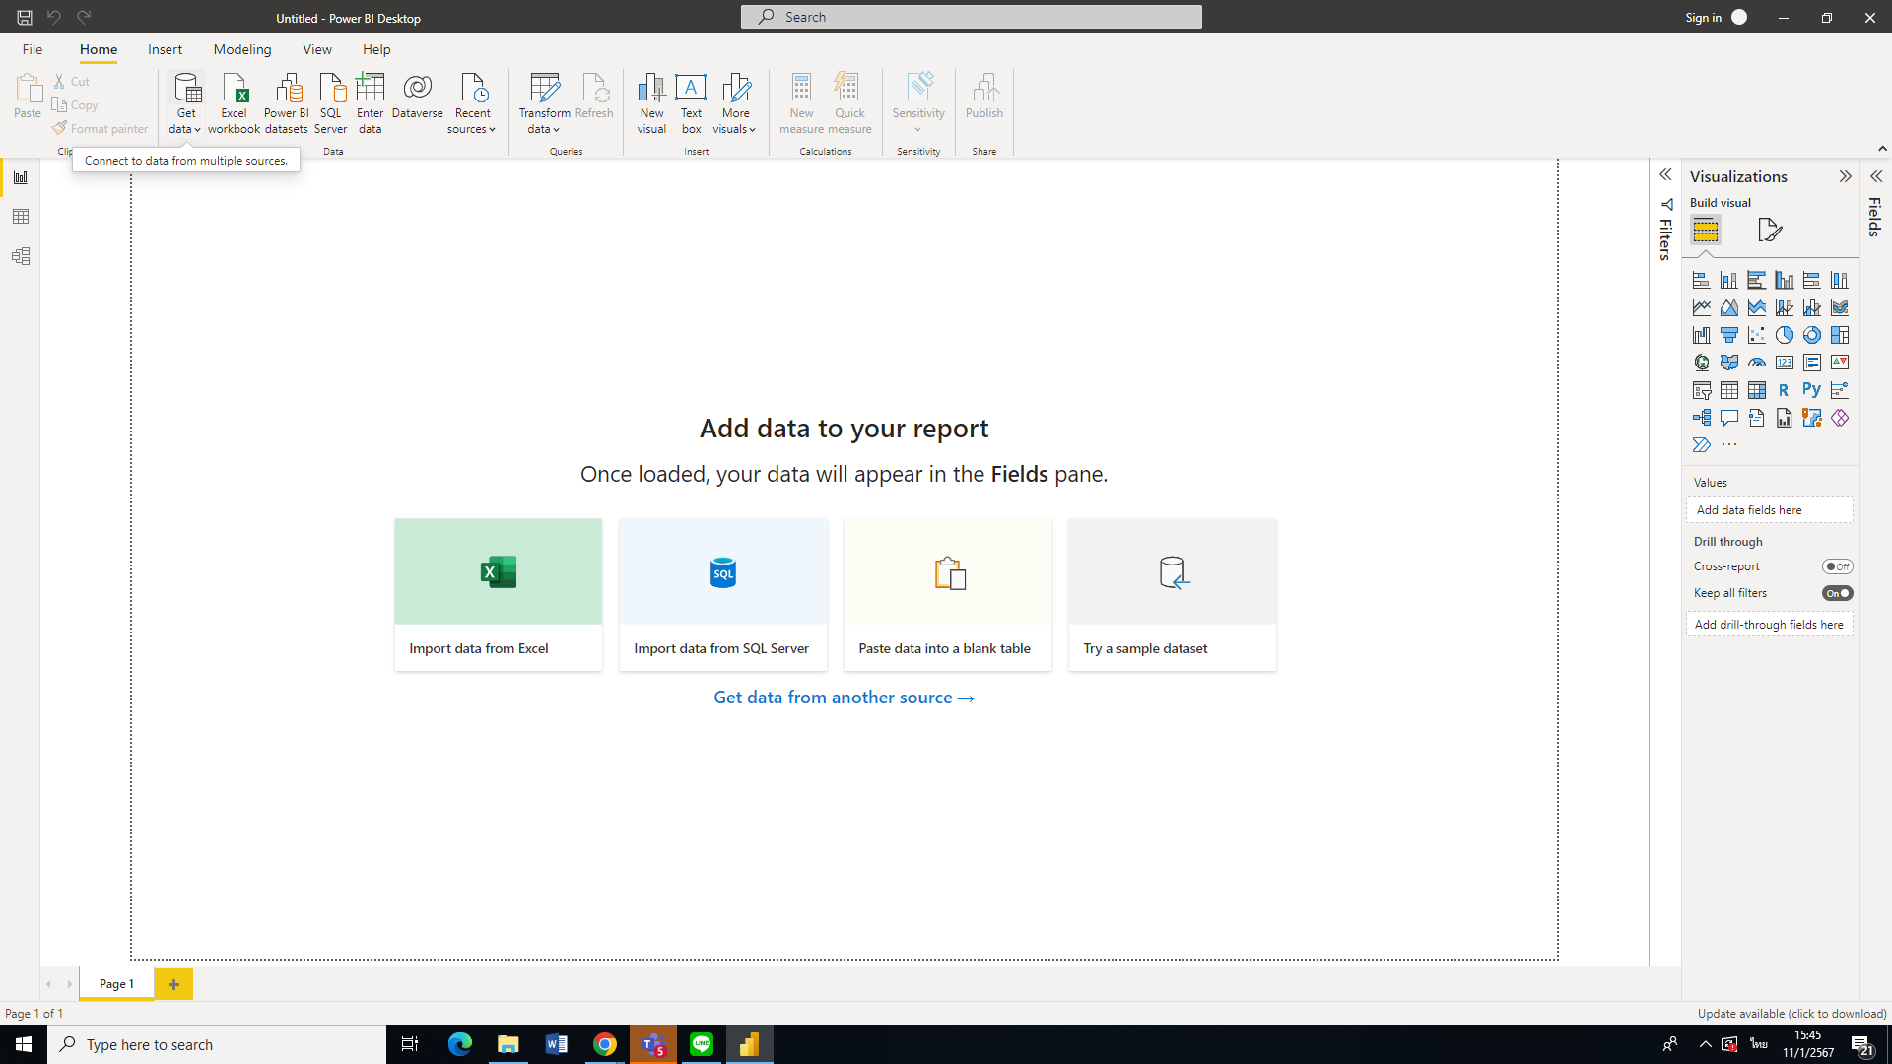

1. Select Excel Workbook and Then Click Connect button ( )

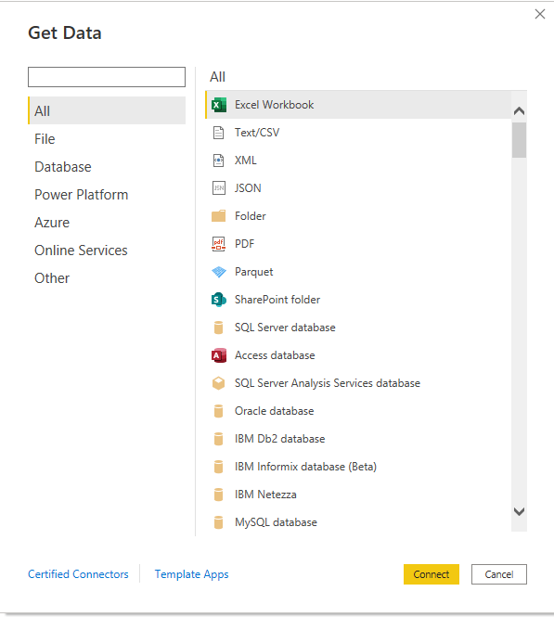

1. Select the file

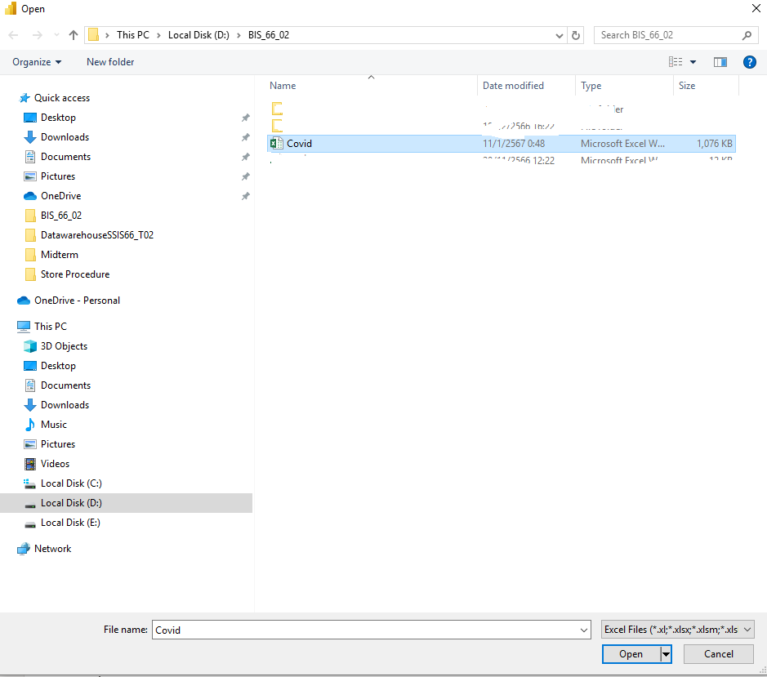

1. Select the Sheet and Click LOAD Button

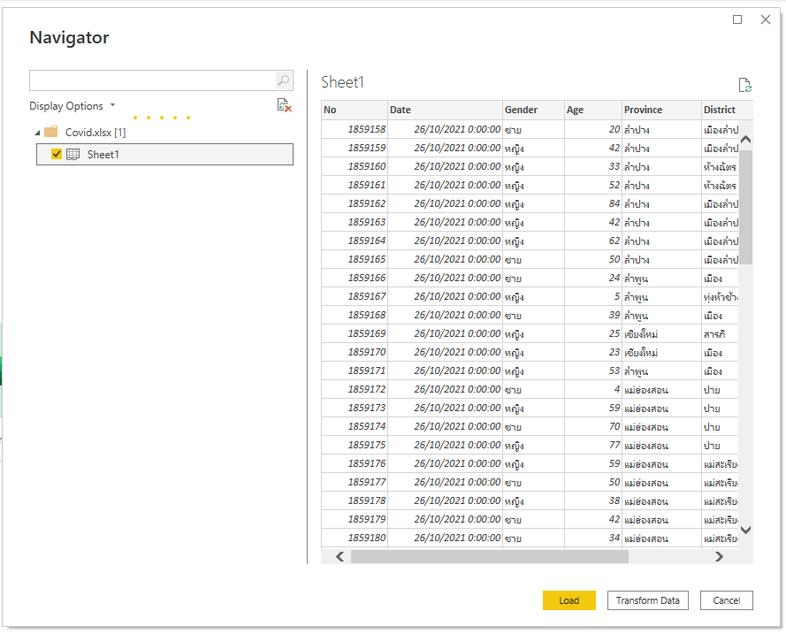

5. Select Clustered bar chart

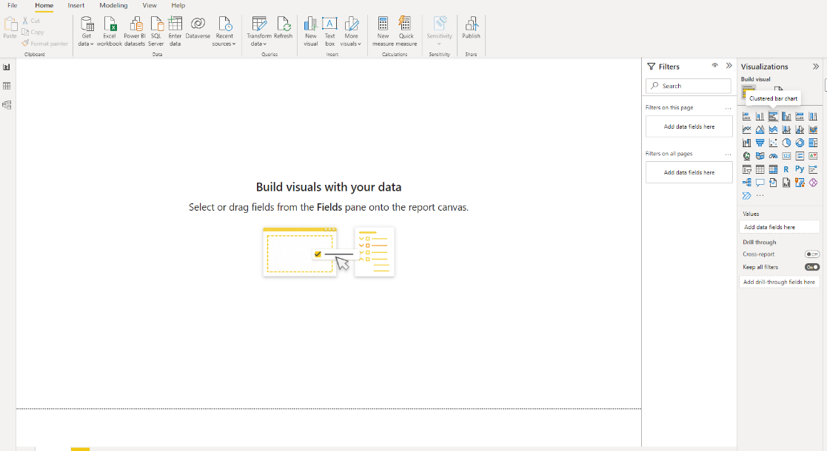

6. Select the chart properties as follows:

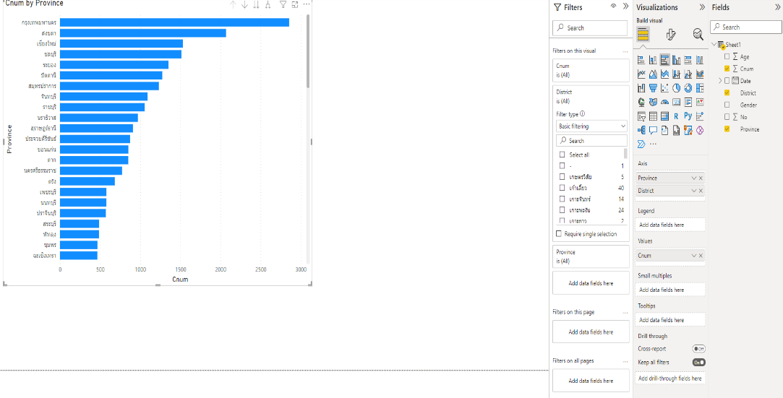

7. If we want to show the Top 5 Province data

7.1 Click the list box of province

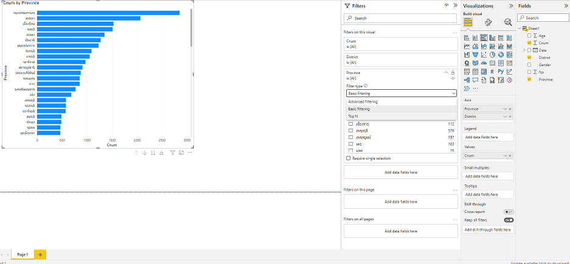

7.2 Set 4 properties as follows:

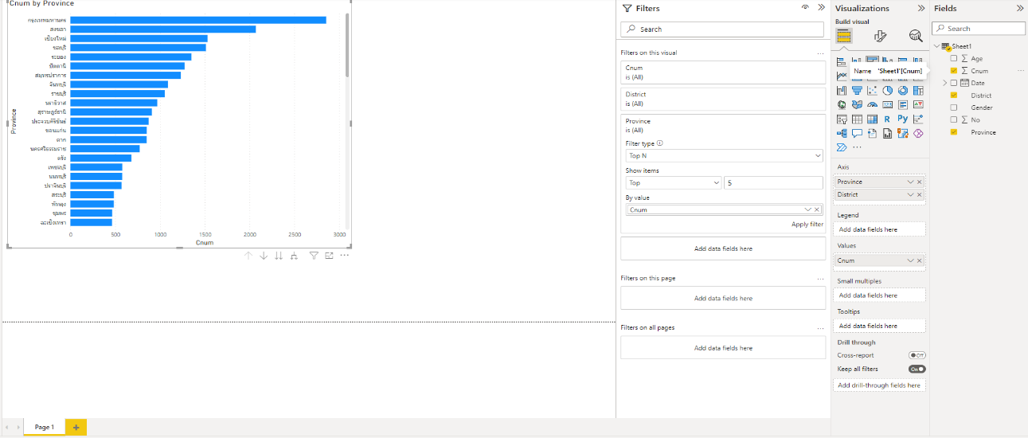

7.3 Click Apply filter

