การ Import Data

1. SQL Server Management Studio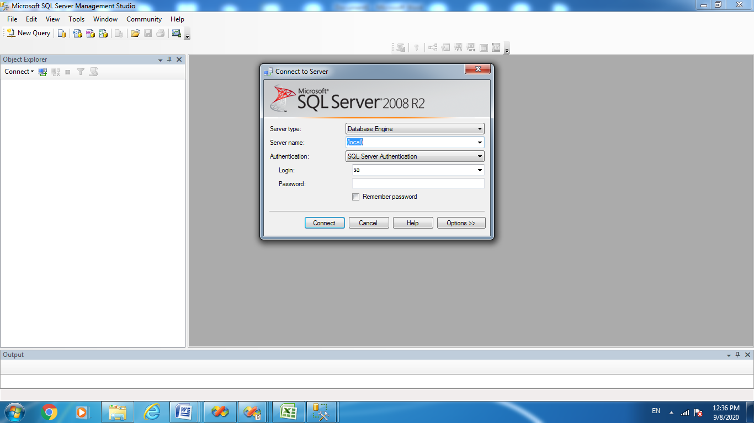

2. Create Database Click Database> Click ขวา เลือก New Database

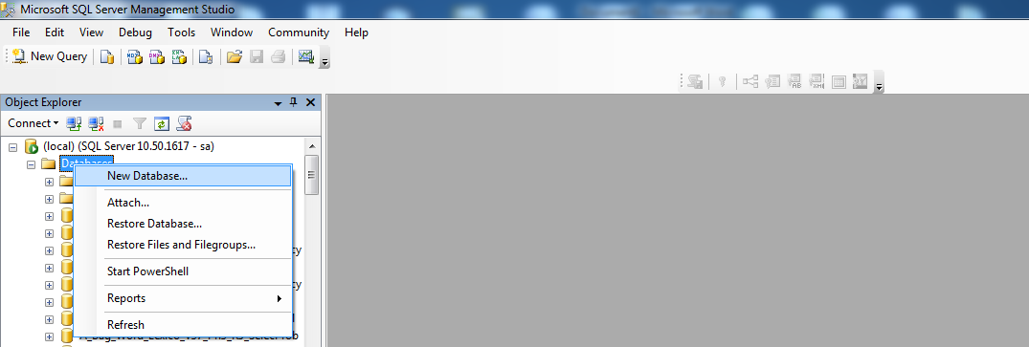

3. ตั้งชื่อ Database ตามต้องการ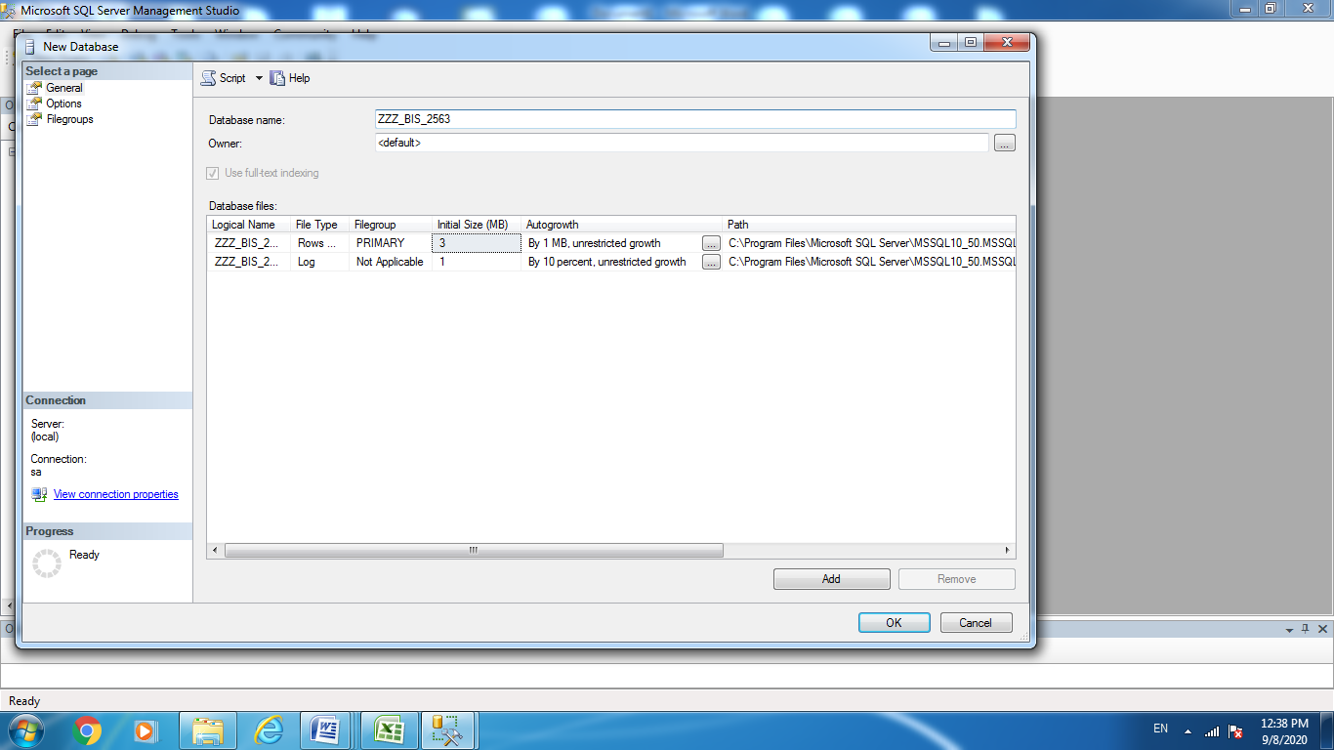

Click ขวา เลือก Task> Import Data

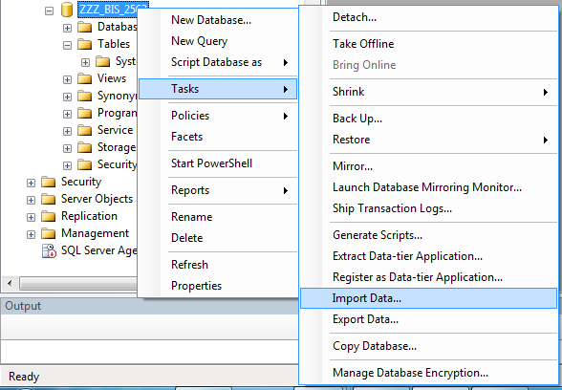

Datasource เลือก Excel เลือก ชื่อ File ที่ต้องการ Import

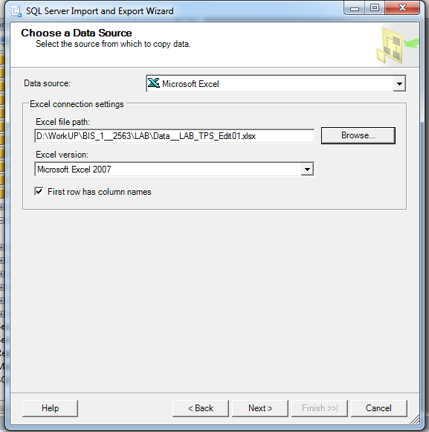

Click Next ไปเรื่อยๆ >>> ขั้นตอนสุดท้ายเลือก Finish

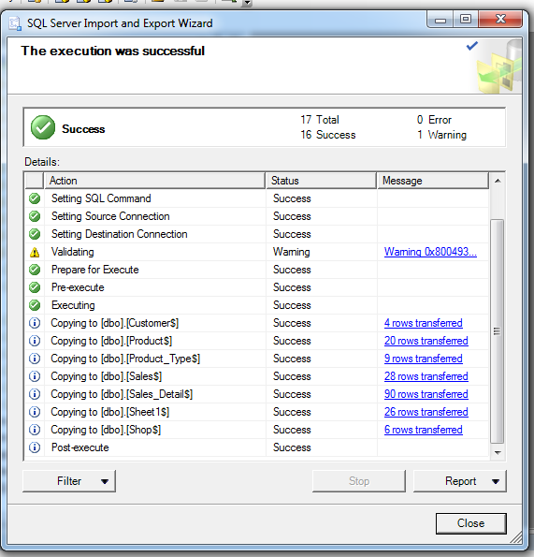

**================== จากนั้นให้ ลองคำสั่ง ==================**

select*from **sales_detail** where **Receipt_No**='R12082563G30001'

**========================================================**

select **B**.Receipt_No,

B.Product_Id,A.Product_NameThai,B.Qty,B.Unit_Price,B.Total_Amt

from **Product A**, **sales_detail B**

where **A**.Product_Id=B.Product_Id

and (Receipt_No='R12082563G30001'

or **Receipt_No**='R20082563G60003'

or **Receipt_No**='R21082563G60003')

orderby **Receipt_No** asc

**=======================================================**

select **B**.Receipt_No,

B.Product_Id,A.Product_NameThai,B.Qty,B.Unit_Price,B.Total_Amt

from **Product A**, **sales_detail B**

where **A**.Product_Id=B.Product_Id

and (Receipt_No='R12082563G30001'

or **Receipt_No**='R20082563G60003'

or **Receipt_No**='R21082563G60003')

orderby **product_Id** asc

=====================================================

select **B**.Receipt_No,

B.Product_Id,A.Product_NameThai, **A**.Product_type_Id,C.Product_Type_Desc,

B.Qty,B.Unit_Price,B.Total_Amt

from **Product A**, **sales_detail B**, **Product_Type C**

where (A.Product_Id=B.Product_Id

and **C**.Product_type_Id = **A**.Product_type_Id)

and (Receipt_No='R12082563G30001'

or **Receipt_No**='R20082563G60003'

or **Receipt_No**='R21082563G60003')

orderby **B**.Receipt_No asc

======================================================================

select **B**.Receipt_No,

B.Product_Id,A.Product_NameThai, **A**.Product_type_Id,C.Product_Type_Desc,

B.Qty,B.Unit_Price,B.Total_Amt

from **Product A**, **sales_detail B**, **Product_Type C**

where (A.Product_Id=B.Product_Id

and **C**.Product_type_Id = **A**.Product_type_Id)

and (Receipt_No='R12082563G30001'

or **Receipt_No**='R20082563G60003'

or **Receipt_No**='R21082563G60003')

orderby **B**.Receipt_No asc

